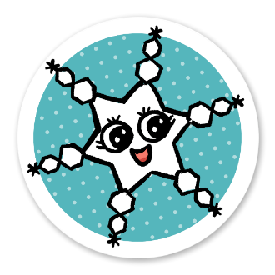

© Sarah Giles for Core Toons

coretoons.substack.com

We don’t want to waste paper, so make a comic with the bottom part of this paper after you cut out your sticker. 😁